CAB302 Software Development

Assignment 2

Callum woodland n100

Joshua want n9723099

# Statement of Completeness

Below is the statement of completeness, features marked with an asterisk most likely have small bugs. These will be expanded upon below.

|  |  |
| --- | --- |
| **Feature** | **Completion** |
| Plot | Y |
| Line | Y |
| Rectangle | Y |
| Ellipse | Y |
| Polygon | N |
| Save | Y* |
| Load | Y* |
| Outline Colour | Y |
| Fill Colour | Y |
| Undo | Y |
| Clear | Y |
| Javadoc | Y |
| Junit 5 | Y |
| Git | Y |
| Additional Functionality | N |

Save: bug related to disabling the fill colour of an object. It also does not save polygons as they are not implemented.

Load: cannot load polygons as they are not implemented.

# Development Process

During the development of this task Agile software development practices were used to ensure efficient and smooth development of features. An iterative design-code-test method was used, we focused on implementing features one at a time, constantly testing and adapting the code to allow for the best implementation of the feature.

Features were implemented in the following stages:

1. GUI and drawing canvas
2. Basic draw functionality
3. Extend draw functionality to include ovals, colours
4. Colour selection for fill and outline
5. Save feature
6. Load feature
7. Undo/Clear

# Statement of Contribution

|  |  |
| --- | --- |
| **Person** | **Contribution** |
| Callum Woodland | Code writing, report, tests |
| Joshua Want | Code writing, report, tests |

# Software Architecture

# Implementation of Object Orientated Programming

## Abstraction

## Encapsulation

## Inheritance

## Polymorphism

# Usage Documentation

1. Open project in IntelliJ
2. Set entry point to main class
3. Run
4. All drawing functions are used by using a click-hold-release method
5. Line and fill colour can be set with the 2 colour boxes in the centre of the GUI bar
6. Save will save the current drawing to the root directory of the project
7. Load will allow you to load vec files from anywhere

If you are unable to run the project you may need to mark the src folder as the source folder

## Functionality showcase

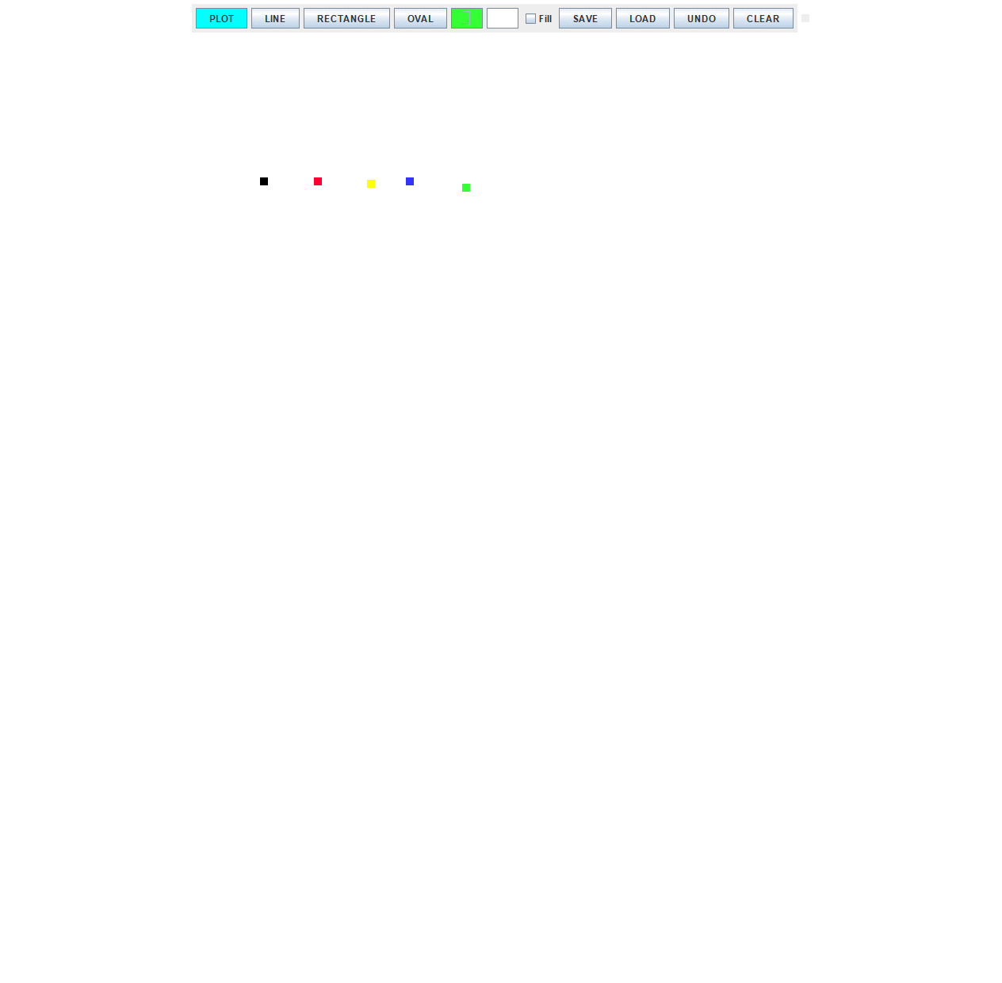Plot with multiple colours

Line with multiple colours

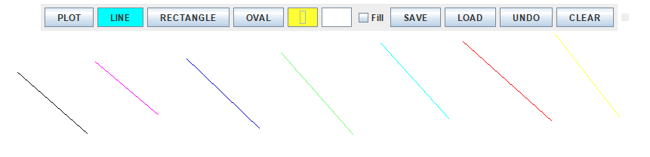

Rectangle with various fill and line colours

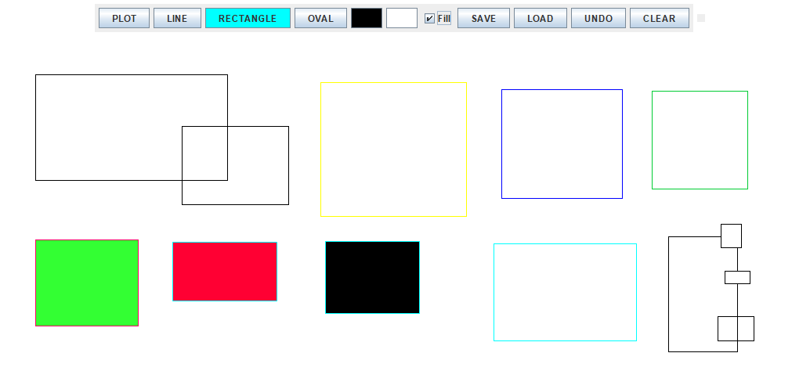

Ellipse with various fill and line colours

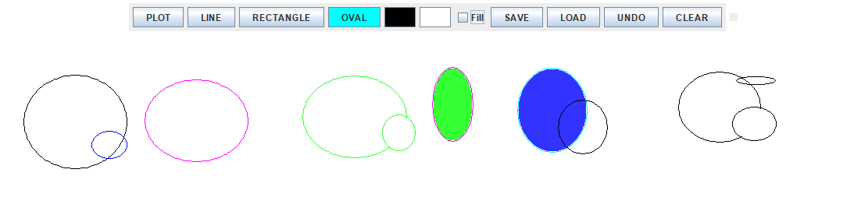

Saved the following drawing

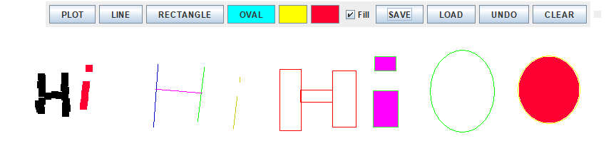

Loaded the generated VEC. It looks a little different cause the save functionality has a bug with fill colours.

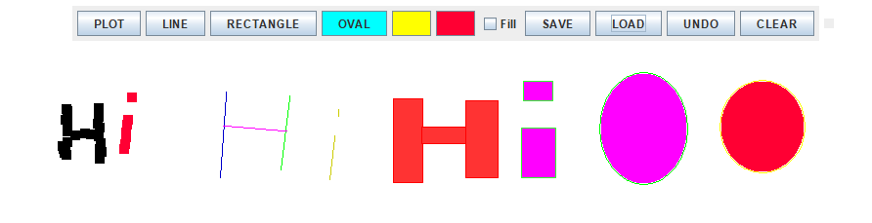

Load example1.vec

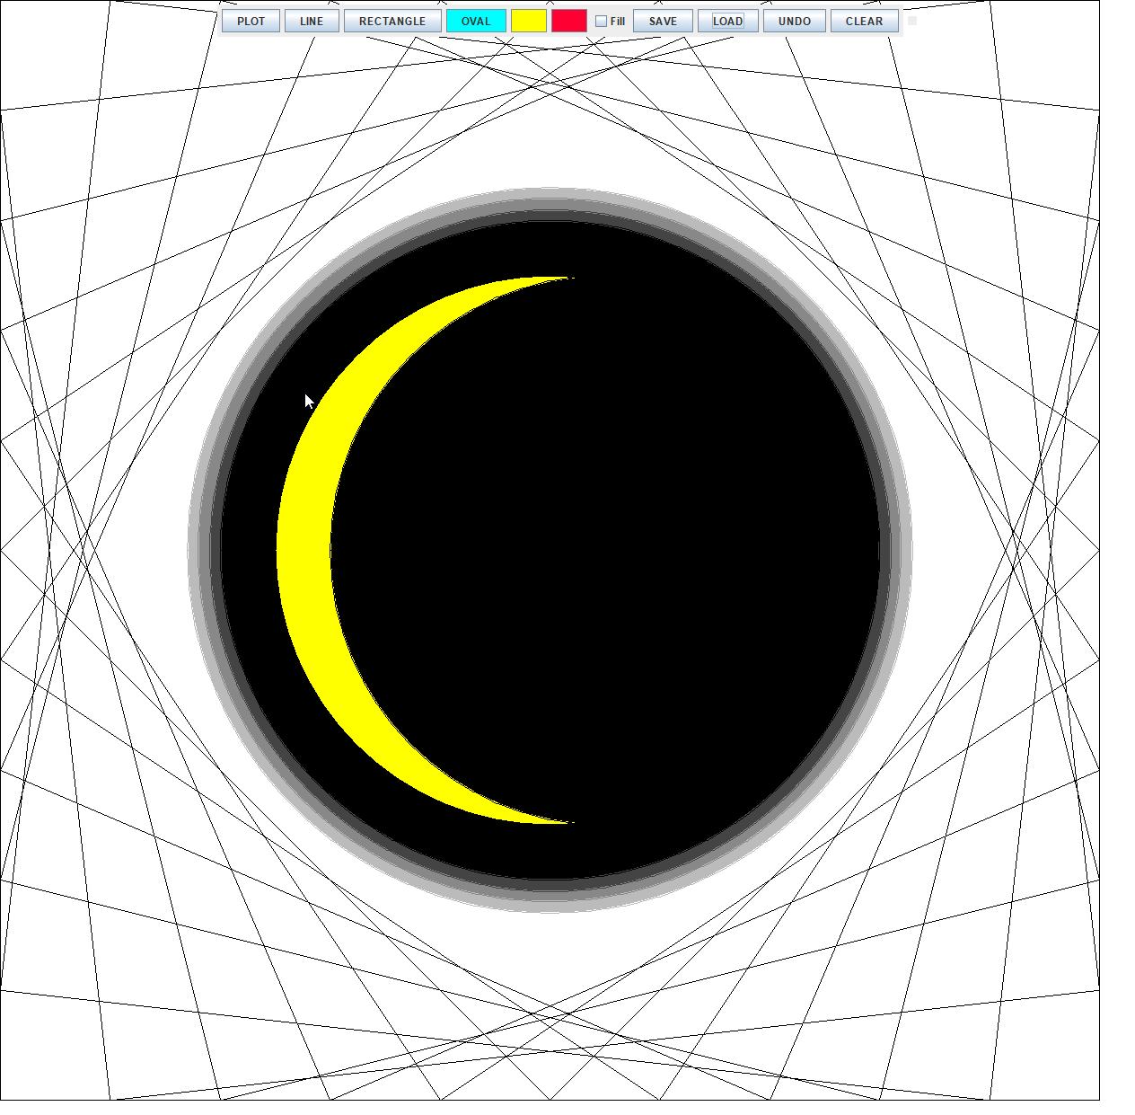

Click undo a few times on the loaded example1.vec

